SuperStart
Peer Mentorship Programme
Executive Committee Briefing Document

From Uneven Start to Structural Asset
A Mentorship Programme Built, Run, and Handed Over by FirstRand's Own Graduates

First Job Programme | Graduate Executive Committee | Mentorship Portfolio

Table of Contents

The Problem That Made SuperStart Necessary 3
What SuperStart Actually Is 3
Design Principles 4
How the Programme Flows from Start to Finish 4
Who Benefits and How 5
Evidence That the Programme Is Already Working 6
The Team Behind It and the Continuity That Matters 6
Why Executive Support Is the Natural Next Step 7
A Closing Thought 8

The Problem That Made SuperStart Necessary
Early career support at FirstRand was never deliberately designed. It was left to circumstance. Some new joiners arrived into teams where managers checked in regularly, where expectations were clear, and where someone seemed to care about how they were settling in. Those joiners learned faster, felt more confident, and understood what success looked like. Others landed in different contexts. Not worse teams necessarily, but busier managers, quieter cultures, less explicit guidance. Their struggle was not about capability or effort. It was about the absence of intentional support.
This unevenness was visible to everyone who paid attention. It was acknowledged in conversations across the First Job Programme. New joiners themselves spoke about it in feedback sessions. Managers observed it in the wide variance of preparedness across different teams. For a long time, however, it remained a described problem rather than an addressed one. The quality of a new joiner's first year depended too much on where they sat and who they drew as a manager. That is a fragile foundation for any talent system.
SuperStart was created as the direct response to this gap. Not a tweak to an existing process. Not an optional add on. A structural solution to a structural problem.

The Core Problem
The quality of a new joiner's first year depended too much on where they sat and who they drew as a manager. That is a fragile foundation for any talent system. SuperStart was created as the direct structural response.

What SuperStart Actually Is
Let us be precise. SuperStart is a time bound, structured mentorship programme designed specifically for early career hires. It operates in five month cycles with a clear beginning, middle, and end. That temporal boundary matters more than it might seem. Open ended mentorship arrangements sound generous but often drift into nothing. A defined cycle creates momentum and shared accountability.
Every mentor and mentee goes through joint onboarding before any mentoring happens. They align on purpose, expectations, boundaries, and cadence. This single design choice has prevented more mismatched relationships than any other feature of the programme. Most failed mentoring arrangements fail because the two parties never had the same picture of what they were there to do. SuperStart closes that gap before it opens.
The programme is organised around guided development themes rather than open conversation. Each phase focuses on specific growth areas such as confidence building, navigating workplace norms, or career clarity. This keeps the relationship productive without making it feel mechanical.
Crucially, SuperStart lives inside Workday. Registration, training, matching, and tracking all happen within the existing talent infrastructure. This is not a separate spreadsheet project run by well meaning graduates in their spare time. It is an embedded process with visibility and governance. The full lifecycle from mentor registration through to close out reporting is hosted on the platform, which means the programme does not depend on any one person or cohort to keep the records straight.
A limitation worth naming openly is that SuperStart does not replace line manager accountability. It cannot. A mentor is not a manager. The programme supplements what managers should already be doing. Where line management is weak, SuperStart provides a lifeline, but it is not a substitute for fixing broken team dynamics. Where line management is strong, SuperStart amplifies and complements it. We have always been clear about that boundary.

Design Principles
These principles guided every decision made in designing SuperStart and shaped how the programme was built to be fair, scalable, and practical. They establish a clear foundation for how support is delivered, how participants engage, and how the programme sustains impact over time.

Principle | What It Means in Practice
Consistency over ad-hoc support | A structured, repeatable experience ensures every participant receives the same level of support, regardless of team or manager. Randomness and individual dependency are designed out.
Equal access to guidance | Access is not influenced by team, role, or confidence level — levelling the playing field across the organisation.
Shared accountability | Both mentors and mentees own progress, engagement, and results — balanced ownership, not burden on one side.
Human-centred, operationally light | Designed for real human development with minimal administrative overhead. Energy goes to people, not process.
Scalable without losing impact | Built to grow across cohorts and departments without becoming diluted or impersonal.

How the Programme Flows from Start to Finish
The end to end journey has been designed to be robust without being bureaucratic. Mentors are identified and confirmed before mentees are even onboarded. That sequencing is deliberate. It signals that mentorship is a valued commitment, not a last minute favour. It also removes the frantic scramble that weakens many peer programmes, where mentors are recruited after mentees are already waiting.
Mentors formally register their participation, which establishes role clarity and a baseline of accountability. This registration step is hosted on Workday, which means there is a clean record of who is participating, what training they have completed, and who they are matched with. Pairings are then made based on development needs, relevant experience, and mutual availability. The matching process is intentional rather than algorithmic or random. A human being considers each pairing, looking for alignment in working styles, career interests, and personal temperament. That human attention increases the likelihood of genuine connection.
Once matched, mentors and mentees train together. This joint onboarding happens through materials hosted on Workday, covering topics such as the purpose of the programme, the boundaries of the mentoring relationship, suggested conversation starters, and how to handle common challenges. By training together rather than separately, both parties enter the relationship with the same set of expectations and the same vocabulary for talking about what is working and what is not.
The five months that follow are supported by regular check ins, prompts, and structured reflection points. Mentors and mentees are encouraged to meet every two to three weeks, with each conversation loosely themed around the development phase they are in. At the midpoint of the cycle, formal feedback is collected from both parties. This is not a box ticking exercise. It is a governance moment that allows course correction before the relationship has run its full course. If a pairing is not working, the midpoint is when that gets identified and addressed. If things are going well, the midpoint reinforces what is working.
At the end of the five months, a second round of feedback is collected. These end of cycle insights are documented, analysed for themes, and used to improve the next cohort. Close out also includes a reporting step where aggregate data on participation, satisfaction, and outcomes is shared with stakeholders. This discipline ensures that the programme learns across cohorts rather than starting from scratch every time.

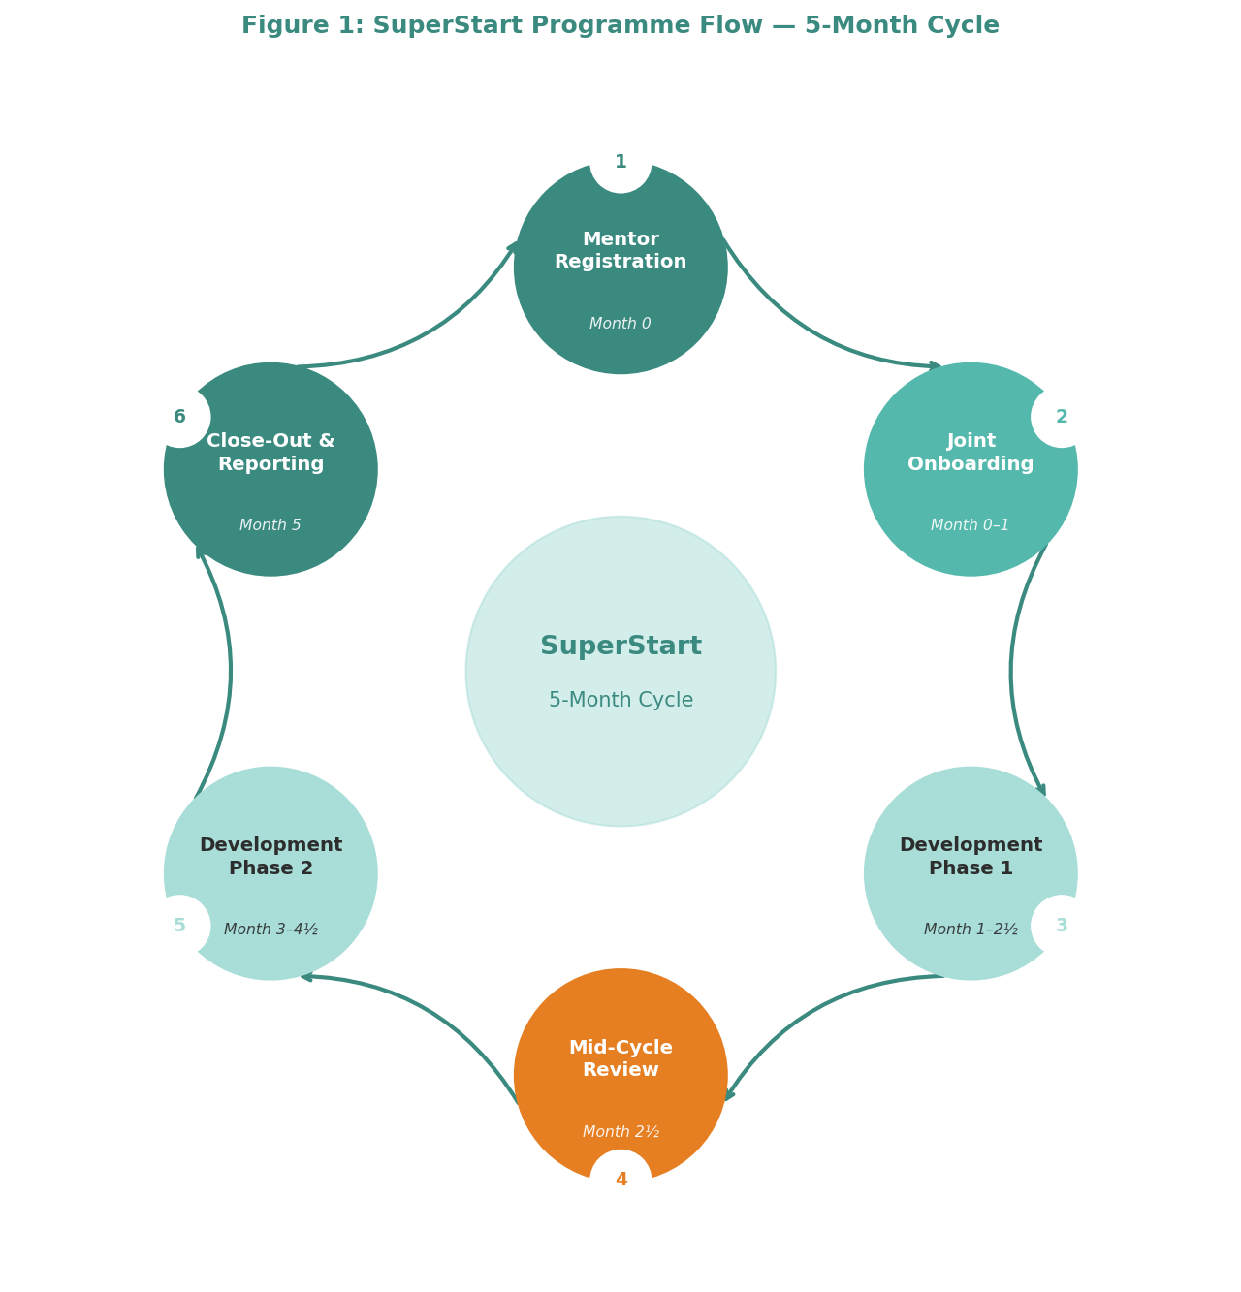
Figure 1: SuperStart Programme Flow — 5-Month Cycle

Who Benefits and How
From the mentee perspective, SuperStart offers something surprisingly rare in a large organisation. It offers a trusted space where they can ask questions, admit confusion, and make mistakes without fear of judgement. That psychological safety is the real currency of the programme. Everything else flows from it. A mentee who feels safe learns faster, takes more productive risks, and recovers more quickly from setbacks.
Mentees build confidence faster because they are not guessing alone. They have someone to test assumptions against, to ask about unwritten rules, to validate whether a concern is reasonable or exaggerated. They gain clarity on role expectations and growth pathways, not because their mentor has formal authority over their progression, but because their mentor has recent experience of navigating the same organisation. They also learn practical workplace skills that are rarely taught formally but are essential for survival and progression. How to run a good meeting. How to read the emotional temperature of a team. How to ask for stretch work without seeming entitled. These are the kinds of things mentors pass on naturally when the relationship is working.
What is often overlooked is how much mentors gain. Serving as a SuperStart mentor is a genuine leadership development experience. Mentors practise coaching, giving constructive feedback, and influencing without formal authority. Many have reported that the programme gave them their first real taste of what it feels like to be responsible for someone else's growth. That is not a small thing for early career employees who may otherwise have no people management exposure for years. The programme also gives mentors a sense of purpose and contribution that desk work alone rarely provides. Knowing that they helped someone through a hard first year is meaningful in a way that delivering a project on time is not.
At an organisational level, SuperStart delivers smoother onboarding, lower early attrition risk, and a healthier learning culture. It signals that FirstRand invests in people from day one, not after they have proven themselves. It also creates a more consistent experience across different teams and business areas, reducing the luck factor that previously shaped early careers.

Stakeholder | What They Gain | Organisational Outcome
Mentees | A trusted space to ask questions, admit confusion, and make mistakes without judgement. Faster confidence, role clarity, and practical workplace skills rarely taught formally. | Faster integration, reduced uncertainty, lower early attrition risk
Mentors | First real leadership development experience — coaching, feedback, and influencing without authority. A sense of purpose that desk work rarely provides. | Broadened capability, readiness for people management, stronger engagement
FirstRand / Business Units | Smoother onboarding, lower attrition risk, healthier learning culture. Signals investment in people from day one. | Consistent experience across teams, reduced luck factor in early careers
First Job Programme | Structural support layer complementing — not replacing — line manager accountability. | More robust programme design, evidence of graduate initiative capability

Evidence That the Programme Is Already Working
Demand has grown without aggressive marketing. First year employees outside the formal First Job Programme have actively expressed interest in peer mentorship. That is significant. It means the need SuperStart addresses is not limited to one cohort or one programme. It is a broader feature of early corporate transition, something that matters to anyone joining the organisation in their first few years, regardless of which specific entry programme brought them in.
Current mentors have referred their peers to join as mentors. Organic advocacy of this kind is hard to fake. People do not recommend things that feel like a waste of their time. They recommend things that have given them genuine satisfaction and growth. The fact that mentors are voluntarily recruiting their colleagues is perhaps the single strongest signal that the programme creates real value for them.
Internal stakeholders, including programme managers and executive sponsors such as Annemarie Vermeulen, have shown strong alignment with SuperStart's objectives. Initial discussions have highlighted executive and operational curiosity around how structured peer mentorship can complement line manager support, improve learner confidence, and strengthen transition readiness. The conversations are no longer about whether peer mentorship makes sense. They are about how to integrate it more deeply into existing talent systems.
Perhaps the most telling evidence is that SuperStart has now run multiple full cycles, handed itself over from the 2025 cohort to the 2026 cohort, and continued to function without degradation. That is rare for graduate led initiatives. Most die or fade when their founders rotate to new roles. SuperStart has done the opposite. It has matured.

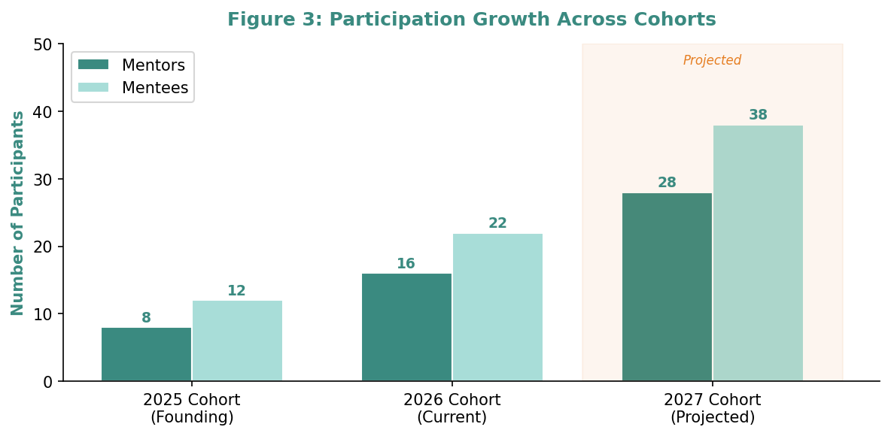
Figure 2: Participation Growth Across Cohorts (2025 founding; 2026 active; 2027 projected)

The Team Behind It and the Continuity That Matters
SuperStart was designed, built, and handed over by two successive graduate cohorts. That fact is not a footnote. It is the central proof that the programme has been built to outlive its founders.
The initial team came from the 2025 Graduate Programme. Nathan Ngqwebo, Noluthando Buthelezi, Malamba Lavhengwa, and Andiswa Mashimbye, operating under the Graduate Executive Committee's Mentorship Portfolio, did the hard work of turning an idea into a running programme. They designed the framework, tested it with early pilots, secured the first mentors, and navigated the ambiguity of building something new inside a large organisation. They were supported by Ntsiki Morrison, Mosa Seloane, and Zaheer Ismail, whose experience and insight helped shape the design and avoid early pitfalls. What the founding team demonstrated was not just competence but commitment. They did not hand over a half finished experiment. They handed over a working programme.
When the 2026 cohort arrived, a new Mentorship Portfolio was appointed. Mikael Zandamela, Morris Nkomo, Nadia Abdul Khaliq, and Zubair Hussain took ownership through a structured handover that preserved context, lessons learned, and strategic direction. The two cohorts worked closely together to expand matching, refine processes, and strengthen governance. The handover was not a single meeting. It was a period of deliberate knowledge transfer, shadowing, and co leadership that ensured nothing was lost.
What makes this worth highlighting is not the list of names. It is that the programme has now been handed over twice without losing momentum. That is rare. Most graduate led initiatives die when their founders rotate to new roles because the knowledge was never written down, the relationships were never transferred, and the momentum was never institutionalised. SuperStart has done the opposite. The programme is now hosted entirely on Workday, which means it no longer depends on any one person or cohort to run. The framework, processes, and principles are embedded in the platform. That is what sustainability looks like.

Role | 2025 Cohort (Founding) | 2026 Cohort (Current)
Mentorship Portfolio | Nathan Ngqwebo, Noluthando Buthelezi, Malamba Lavhengwa, Andiswa Mashimbye | Mikael Zandamela, Morris Nkomo, Nadia Abdul Khaliq, Zubair Hussain
Advisors / Support | Ntsiki Morrison, Mosa Seloane, Zaheer Ismail | —
Executive Sponsor | Annemarie Vermeulen | Annemarie Vermeulen
Key Achievement | Designed framework, ran pilots, secured first mentors, embedded in Workday, handed over a working programme | Expanded matching, refined processes, strengthened governance, co-led transition period

Continuity as Proof of Design
The programme has been handed over twice between graduate cohorts without losing momentum or quality. Most graduate-led initiatives fade when founders rotate. SuperStart has done the opposite — it has matured. The framework, processes, and principles are embedded in Workday, independent of any one person or cohort. That is what sustainability looks like.

Why Executive Support Is the Natural Next Step
SuperStart has already proven it can run end to end. It has proven it can hand itself over. It has proven it can grow without being pushed. It has proven that mentors value the experience enough to recruit their peers. It has proven that mentees find genuine safety and clarity in the relationship. What it does not yet have is official standing. That is what this ask is about.
The first request is for formal endorsement from Exco to position SuperStart as the Bank's official peer mentorship advocate for First Job learners. Endorsement removes ambiguity about legitimacy and longevity. It signals to the wider organisation that this is not a graduate side project but a recognised capability. It also protects the programme from the inevitable question that kills good ideas: who said we could do this. With endorsement, the answer is clear and final.
The second request is for continued and deepened integration into existing talent ecosystems. Specifically, formalising SuperStart's role within the First Job support model, particularly through integration into the work readiness portion of that programme. And expanding SuperStart's contribution into the FNB Graduate Programme through a structured buddy mentorship approach. This integration would create a seamless early career transition arc without duplicating effort across different parts of the organisation.
The third request is for visibility and active sponsorship. A programme like this needs more than quiet competence. It needs visible advocacy. Executive acknowledgement in talent communications and forums would strengthen mentor recruitment by signalling that serving as a mentor is recognised as a development opportunity, not an extra chore. Visibility also helps attract mentees who might otherwise be hesitant to put their hand up and ask for help.
The fourth request is for permission and support to scale mentor sourcing. The current mentor pool is limited to the graduate cohort. That is too narrow for the demand that already exists. With executive support, SuperStart could approach a broader group of early career employees who are sufficiently settled in their roles. Managers would need to be aligned to encourage participation, and mentorship would need to be positioned as a recognised developmental opportunity rather than a distraction from day jobs. But the ask is not for budget. It is for permission and air cover.

Request | Detail
1. Formal Exco Endorsement | Position SuperStart as the Bank's official peer mentorship advocate for First Job learners. Removes ambiguity about legitimacy and longevity, and answers the question that kills good ideas: "who said we could do this."
2. Talent Ecosystem Integration | Formalise SuperStart's role within the First Job support model — particularly the work readiness portion. Expand into the FNB Graduate Programme through a structured buddy mentorship approach, creating a seamless early career arc without duplicating effort.
3. Visibility & Active Sponsorship | Executive acknowledgement in talent communications and forums. Signals mentorship as a recognised development opportunity, not an extra chore. Helps attract mentees who might otherwise hesitate to ask for help.
4. Expanded Mentor Sourcing | Permission and air cover to recruit beyond the graduate cohort to broader early career employees. No budget requested — only management alignment and permission.

A Closing Thought
SuperStart is more than a programme. It is a commitment that no one at FirstRand should start their career feeling unsupported, uncertain, or alone. That commitment has already been honoured across two graduate cohorts. It has been embedded into Workday. It has attracted demand from people outside its original scope. And it has done all of this without executive endorsement or formal standing.
What the programme needs now is not rescue or funding. It is recognition. Permission to be what it already is. Official standing to match its actual contribution. A seat at the talent table.

The Ask in One Sentence
This is not a request for the organisation to take a chance on something untested. It is a request for the organisation to recognise what its own graduates have already built — and to give it the platform it has earned.

